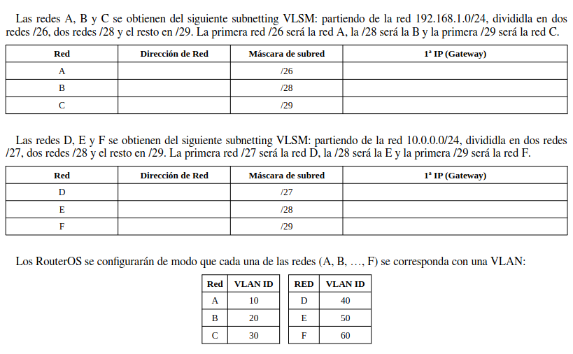

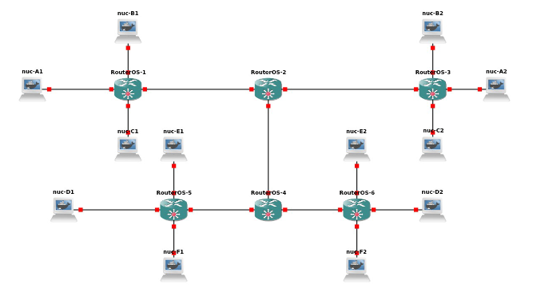

**192.168.1.0/24**

**2 redes /26, dos redes /28 y el resto en /29**

* 192.168.1. 00 000000 A 192.168.1.0 /26
* 192.168.1. 01 000000
* 192.168.1. 1000 0000 B 192.168.1.0/28
* 192.168.1. 1001 0000
* 192.168.1. 10100 000 C 192.168.1.0/29
* 192.168.1. 10101 000

**10.0.0.0/24**

**2 redes /27, dos redes /28 y el resto en /29**

* 10.0.0. 000 00000 D 10.0.0.0/27
* 10.0.0. 001 00000
* 10.0.0. 0100 0000 E 10.0.0.0/28
* 10.0.0. 0101 0000
* 10.0.0. 01100 000 F 10.0.0.0/29

**R2:**

system/identity/set name=R2

interface/bridge/add vlan-filtering=yes

interface/bridge/port/add bridge=bridge1 interface=ether4

interface/bridge/port/add bridge=bridge1 interface=ether5

interface/bridge/port/add bridge=bridge1 interface=ether6

interface/bridge/vlan/add bridge=bridge1 vlan-ids=10 tagged=ether4,ether5,ether6,bridge1

interface/bridge/vlan/add bridge=bridge1 vlan-ids=20 tagged=ether4,ether5,ether6,bridge1

interface/bridge/vlan/add bridge=bridge1 vlan-ids=30 tagged=ether4,ether5,ether6,bridge1

interface/bridge/vlan/add bridge=bridge1 vlan-ids=40 tagged=ether4,ether5,ether6,bridge1

interface/bridge/vlan/add bridge=bridge1 vlan-ids=50 tagged=ether4,ether5,ether6,bridge1

interface/bridge/vlan/add bridge=bridge1 vlan-ids=60 tagged=ether4,ether5,ether6,bridge1

interface/vlan/add interface=bridge1 vlan-id=10 name=vlan10

interface/vlan/add interface=bridge1 vlan-id=20 name=vlan20

interface/vlan/add interface=bridge1 vlan-id=30 name=vlan30

interface/vlan/add interface=bridge1 vlan-id=40 name=vlan40

interface/vlan/add interface=bridge1 vlan-id=50 name=vlan50

interface/vlan/add interface=bridge1 vlan-id=60 name=vlan60

ip/address/add interface=vlan10 address=192.168.1.1/26

ip/address/add interface=vlan20 address=192.168.1.129/28

ip/address/add interface=vlan30 address=192.168.1.161/29

ip/address/add interface=vlan40 address=10.0.0.1/27

ip/address/add interface=vlan50 address=10.0.0.65/28

ip/address/add interface=vlan60 address=10.0.0.97/29

ip/dhcp-server/setup

* vlan10…
* vlan20….
* vlan30….
* …………

**R5:**

system/identity/set name=R5

interface/bridge/add vlan-filtering=yes

interface/bridge/port/add bridge=bridge1 interface=ether4

interface/bridge/port/add bridge=bridge1 interface=ether5

interface/bridge/port/add bridge=bridge1 interface=ether6

interface/bridge/vlan/add bridge=bridge1 tagged=ether4,ether5,ether6 vlan-ids=10

interface/bridge/vlan/add bridge=bridge1 tagged=ether4,ether5,ether6 vlan-ids=20

interface/bridge/vlan/add bridge=bridge1 tagged=ether4,ether5,ether6 vlan-ids=30

interface/bridge/vlan/add bridge=bridge1 tagged=ether4,ether5,ether6 vlan-ids=40

interface/bridge/vlan/add bridge=bridge1 tagged=ether4,ether5,ether6 vlan-ids=50

interface/bridge/vlan/add bridge=bridge1 tagged=ether4,ether5,ether6 vlan-ids=60

**R4:**

system/identity/set name=R4

interface/bridge/add vlan-filtering=yes

interface/bridge/port/add bridge=bridge1 interface=ether1 pvid=40

interface/bridge/port/add bridge=bridge1 interface=ether2 pvid=50

interface/bridge/port/add bridge=bridge1 interface=ether3 pvid=60

interface/bridge/port/add bridge=bridge1 interface=ether6

interface/bridge/vlan/add bridge=bridge1 tagged=ether6 untagged=ether1 vlan-ids=40

interface/bridge/vlan/add bridge=bridge1 tagged=ether6 untagged=ether2 vlan-ids=50

interface/bridge/vlan/add bridge=bridge1 tagged=ether6 untagged=ether3 vlan-ids=60